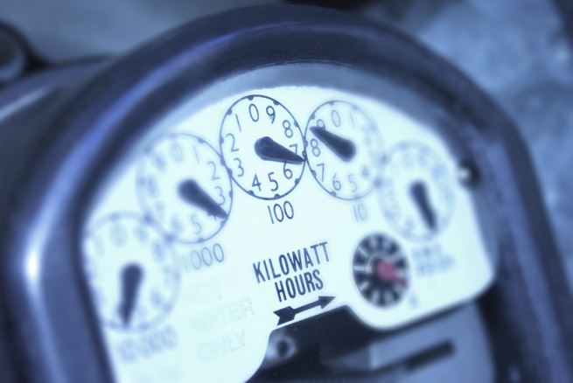
Name_____________________________________________________________Date____________________Period ___
Electrical Energy Inventory Sheet
The cost of electrical energy as of September 2013 in the Memphis area was approximately $0.065kWh
Important tips to remember
- Volts x amps=wattage
- Divide watts by 1,000 to get kW
Find 5 appliances at home and calculate what it is costing your family to use them daily and monthly.
Appliance | watts | kW  (divide by 1,000) | Hours used each day | Electrical energy used  (kW x hours used) | Cost per kWh  (energy used x cost per kWh) | Cost to operate per day | Cost to operate per month  (multiply by 30)
Example: lamp | 250 | .25 | 2 | .5 | .065 | .0325 | .975 (about $ 0.98)
1. |  |  |  |  | .065
2. |  |  |  |  | .065
3. |  |  |  |  | .065
4. |  |  |  |  | .065
5. |  |  |  |  | .065

6. What type of appliances cost more to operate? ____________________________________________________________________________

7. Why do you think this is so? _____________________________________________________________________________

Name_____________________________________________________________Date____________________Period ___
Electrical Energy Inventory Sheet
The cost of electrical energy as of September 2013 in the Memphis area was approximately $0.065kWh
Important tips to remember
- Volts x amps=wattage
- Divide watts by 1,000 to get kW
Find 5 appliances at home and calculate what it is costing your family to use them daily and monthly.
Appliance | watts | kW  (divide by 1,000) | Hours used each day | Electrical energy used  (kW x hours used) | Cost per kWh  (energy used x cost per kWh) | Cost to operate per day | Cost to operate per month  (multiply by 30)
Example: lamp | 250 | .25 | 2 | .5 | .065 | .0325 | .975 (about $ 0.98)
1. |  |  |  |  | .065
2. |  |  |  |  | .065
3. |  |  |  |  | .065
4. |  |  |  |  | .065
5. |  |  |  |  | .065

6. What type of appliances cost more to operate? _____________________________________________________________________________

7. Why do you think this is so? _____________________________________________________________________________

